Listening

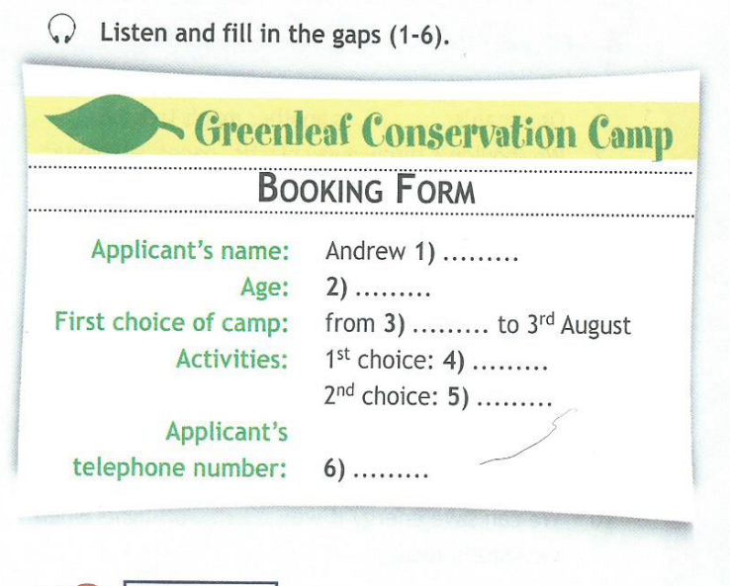

Reading
Read the article, then choose the correct answer(A, B, C or D) for questions 1-7
1. Xiang Xiang was the first panda...
- not born in the wild.
- released after 40 years in captivity.
- that lived in the forest.
- born in captivity and then released into the wild
2. The radio collar...
- tells scientists where Xiang Xiang is.
- plays music.
- makes Xiang Xiang Bark.
- takes photographs.
3. Scientists at Wolong Nature reserve will...
- reduce panda numbers.
- release a certain number of pandas.
- move panda out of the area.
- take more pandas into captivity.
4. Which of the following can you not find at the Panda centre?
- Over 100 pandas
- Open spaces
- Bamboo
- Wild pandas
5. The greatest danger to pandas is...
- the Chinese government.
- farming.
- decreasing habitats
- consevationalists.
6. The Chengdu Research Base...
- is a natural environment for pandas.
- has 28 safe area for pandas.
- only has 6 pandas.
- has a lot more pandas than when it was first opened.
7. It is more important to...
- find more pandas.
- release pandas into the wild.
- protect panda habitats.
- stop keeping pandas in captivity.

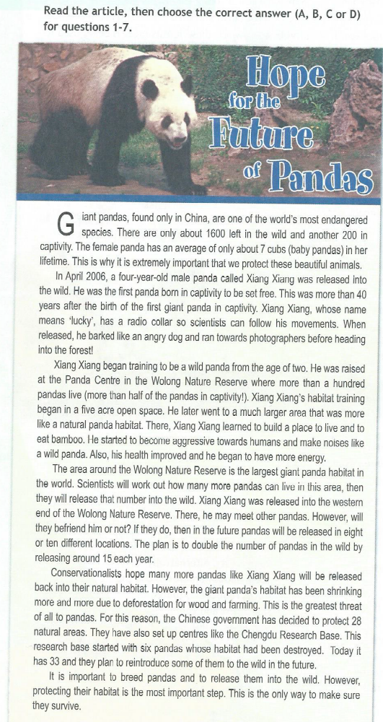

Use of English (I)
Choose the correct variant
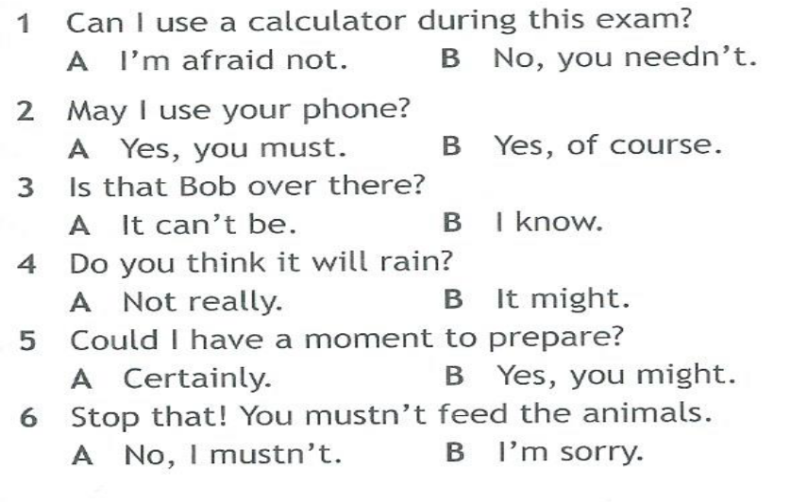
Use of English (II)
Rewrite the sentences using the words in brackets as in the example
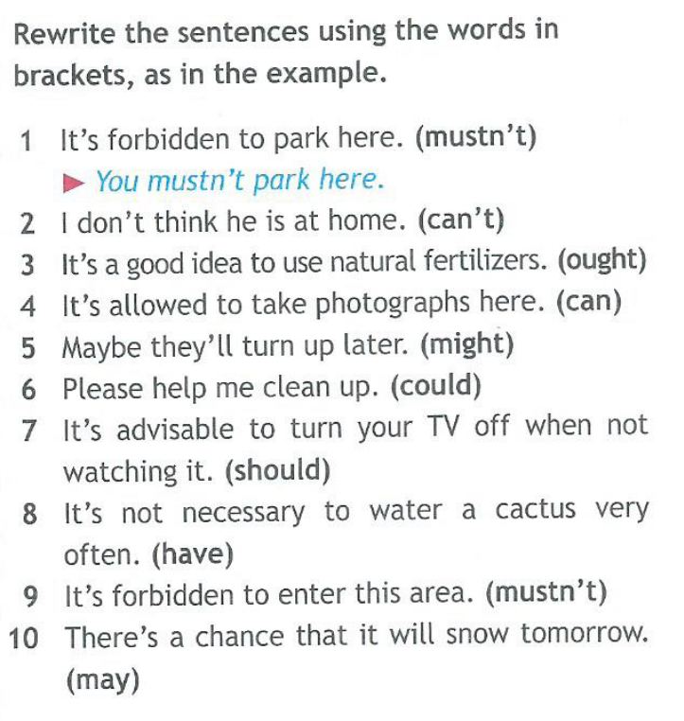
Use of English (III)
What do the modal verbs in bold express?

- prohibition
- absence of necessity
- obligation
- necessity
- possibility
- asking for permission
- negative logical assumption
- request
- advice

- You mustn't dump rubbish here. - prohibition
- He ought to cycle to work more often.
- He can't have failed the exam.
- We should plant more trees in the neighborhood.
- You needn't come to work in the morning.
- You must fill out this form first.
- We have to reduce waste.
- May I have your name, please?
- I think it might snow soon.
- Could I turn the light off, please?

